House Price Prediction Using Linear Regression REPORT
By Tanish Salian (MITADT)
1. Objective
The objective of this project is to develop a Linear Regression model to predict house prices using the California Housing dataset. The project demonstrates the complete machine learning workflow including data preprocessing, exploratory data analysis (EDA), model training, evaluation, and interpretation of results.

2. Dataset Description
The California Housing dataset contains housing information collected from various districts in California. The dataset consists of 20,640 records and 10 attributes.
Features Used
- Longitude
- Latitude
- Housing Median Age
- Total Rooms
- Total Bedrooms
- Population
- Households
- Median Income
- Ocean Proximity
Target Variable
- Median House Value
The dataset contained 207 missing values in the total_bedrooms column, which were replaced using the median value of the column.

3. Exploratory Data Analysis (EDA)
Several exploratory analysis techniques were performed to understand the dataset.

Missing Values Analysis
Only the total_bedrooms column contained missing values. All missing values were handled using median imputation.
Distribution Analysis
A histogram of median house values showed that most properties are concentrated within the lower and middle price ranges, while fewer houses exist in the higher price range.
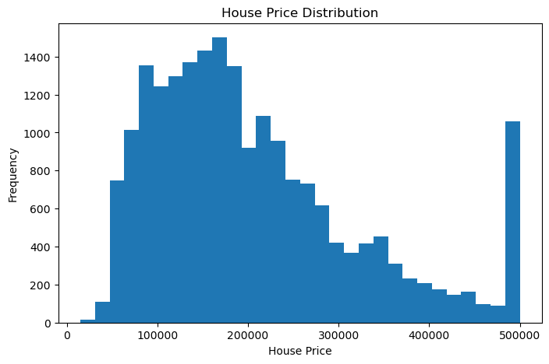

Correlation Analysis
The correlation matrix revealed that median_income has the strongest positive relationship with house prices. Features such as location (longitude and latitude) also influence housing prices.
Feature Relationship
A scatter plot between median income and house prices indicated a clear positive trend, showing that areas with higher income levels generally have higher house prices.

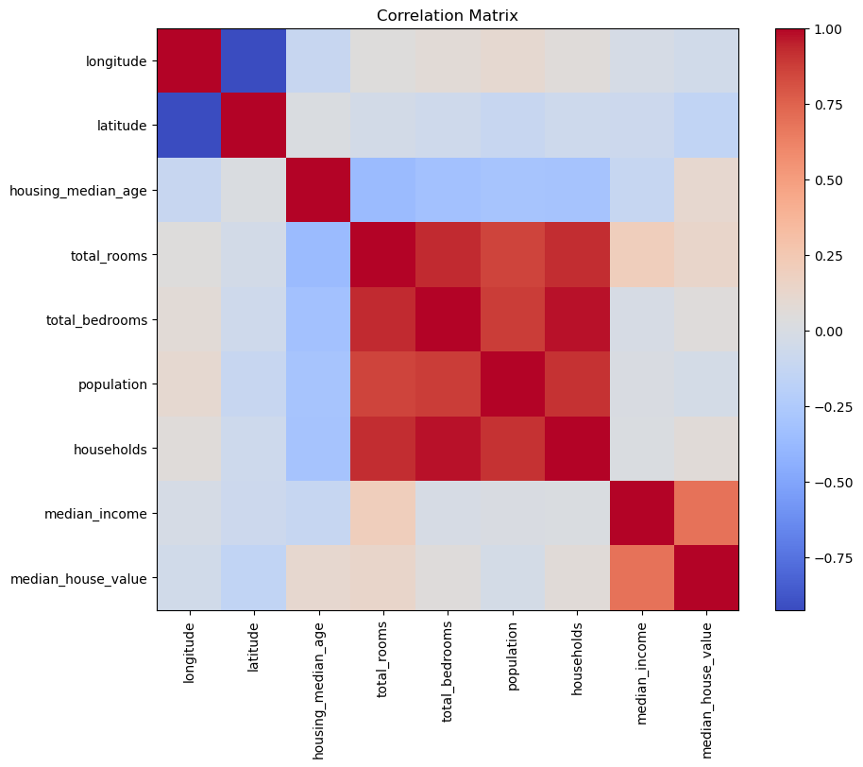

4. Model Development
The categorical feature ocean_proximity was converted into numerical form using one-hot encoding.
The dataset was divided into:
- Training Data: 80%
- Testing Data: 20%
A Linear Regression model was trained using the training dataset and tested on unseen data.

5. Model Evaluation
The model performance was evaluated using standard regression metrics.
Mean Absolute Error (MAE)
MAE measures the average absolute difference between actual and predicted house prices.
MAE = 50,670.74
Root Mean Squared Error (RMSE)
RMSE measures prediction error while giving more importance to larger errors.
RMSE = 70,060.52
R² Score
The R² score indicates how much variance in the target variable is explained by the model.
R² Score = 0.6254
This means the model explains approximately 62.54% of the variation in house prices.
Important Features
The Linear Regression coefficients indicate that the most influential features are:
- Median Income
- Ocean Proximity (Island)
- Housing Median Age
- Latitude and Longitude
Among all features, Median Income had the strongest positive influence on house prices.

6. Results
The Actual vs Predicted scatter plot showed a positive relationship between predicted and actual house prices, indicating that the model captures the overall trend of the data.
The Residual Plot displayed prediction errors around the zero line, suggesting that the model performs reasonably well, although some prediction errors remain for higher-priced properties.

INCOME VS HOUSE PRICE
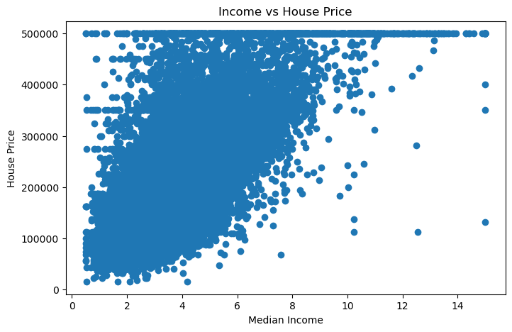
ACTUAL VS PREDICTED SCATTERPLOT
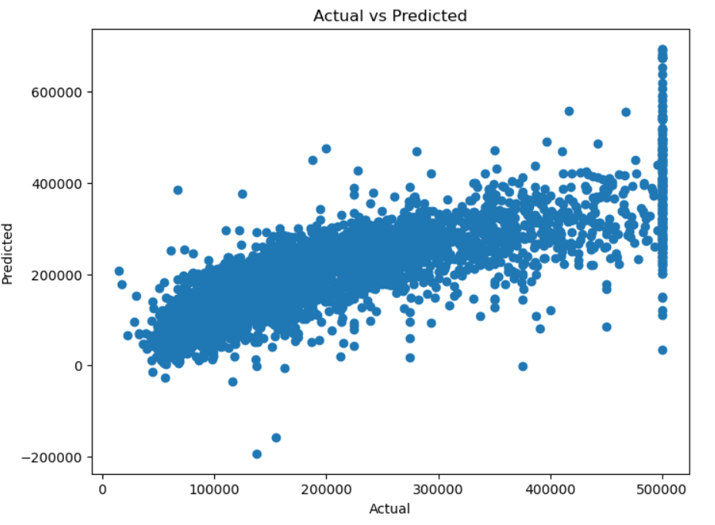
RESIDUAL PLOT
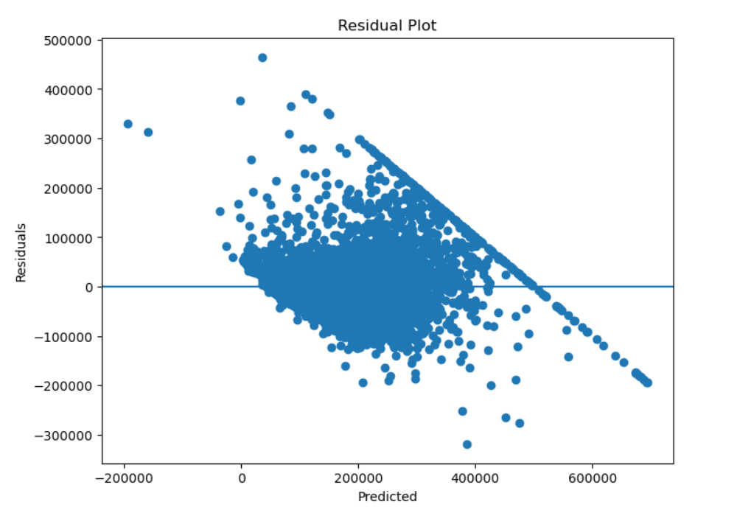

7. Conclusion
A Linear Regression model was successfully developed to predict house prices using the California Housing dataset.
The dataset was cleaned, analyzed, and preprocessed before training. The model achieved an R² score of 0.6254, indicating moderate predictive performance. Exploratory analysis revealed that median income is the most significant factor affecting house prices.
Overall, the model provides a good baseline for house price prediction and demonstrates the application of supervised machine learning techniques to real-world data.

8. Future Improvements
The following enhancements can improve prediction accuracy:
- Feature engineering
- Data normalization and scaling
- Outlier detection and removal
- Hyperparameter optimization
- Using advanced models such as:
  - Random Forest Regressor
  - Gradient Boosting Regressor
  - XGBoost Regressor
These techniques may increase the predictive performance beyond the current Linear Regression model.

